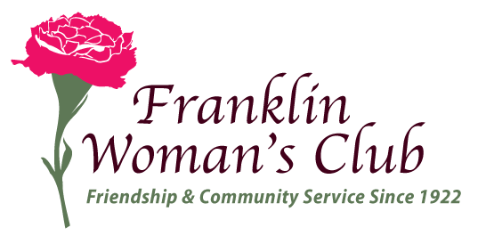

Media Release Form

I,____________________________________________________________
Print Full Name/Business or Organization Name + Location)

_______ Grant Permission
_______ Do NOT Grant Permission
for the Franklin Woman’s Club to include my name/business or organization name/location/photo/video or a statement/testimony about the initiative in press releases or on the Franklin Woman’s Club’s website and/or Facebook page. The club uses this information to educate the public about Woman’s Club projects and initiatives.
I understand that as a result of the press release, photos or videos, my name/organization/business name/location may be published in regular or online publications and/or on television as related to Franklin Woman’s Club initiatives.

__________________________________________________________________
Signature Date

